Explorer

|  |  |  |
| --- | --- | --- |
| Project Design Document | |  | | --- | | *27.06.2022*  Alf Scherer | |

|  |  |  |  |
| --- | --- | --- | --- |
| Project Concept | | | |
| 1 **Player Control** |  | You control a   |  | | --- | | *Scout for an early medieval construction team* | | in this   |  |  | | --- | --- | | *Isometric* | game | |
|  | where   |  | | --- | | *A character controller* | | makes the player   |  | | --- | | *Explore a simple castle with lots of abandoned resources* | |

|  |  |  |  |  |  |  |
| --- | --- | --- | --- | --- | --- | --- |
| 2 **Basic**  **Gameplay** |  | During the game,   |  |  | | --- | --- | | *Tools, materials, and workmen* | appear | | from   |  | | --- | | *In different parts of the castle* | |
|  | and the goal of the game is to   |  | | --- | | *Find all the hidden items (and later use them to construct a church on a nearby site)* | | |

|  |  |  |  |  |  |
| --- | --- | --- | --- | --- | --- |
| 3 **Sound**  **& Effects** |  | There will be sound effects   |  | | --- | | *Nope, maybe later* | | and particle effects   |  | | --- | | *None, only a slight glow on each ItemObject* | |
|  | [*optional*] There will also be   |  | | --- | | *An inventory tally sheet keeping track of items already discovered* | | |

|  |  |  |  |  |  |
| --- | --- | --- | --- | --- | --- |
| 4 **Gameplay**  **Mechanics** |  | As the game progresses,   |  | | --- | | *Discovered items and their classes are listed on inventory sheet. Each new item improves our construction abilities.* | | making it   |  | | --- | | *Easier to build a church in level 2* | |
|  | [*optional*] There will also be   |  | | --- | | *Interplay between workmen, materials and tools depending on ability and function* | | |

|  |  |  |  |  |  |  |  |
| --- | --- | --- | --- | --- | --- | --- | --- |
| 5 **User**  **Interface** |  | The   |  | | --- | | *Score* | | will   |  | | --- | | *increase* | | whenever   |  | | --- | | *An item is discovered, and a new structure is constructed* | |
|  | At the start of the game, the title   |  |  | | --- | --- | | *Abandoned Castle* | will appear | | | and the game will end when   |  | | --- | | *Church in level 2 is constructed* | |

|  |  |  |  |
| --- | --- | --- | --- |
| 6 **Other Features** |  | |  | | --- | | *Key is to retain the feeling that we are a construction project manager, not God. We are Interacting with workmen, tools, and construction materials always at* ***eye level****, and not a side view or a bird's eye view. The challenge Is to keep your orientation of who needs what and what needs to be where and so successfully build a church from the castle ruins.* | |

# 

# Project Timeline

|  |  |  |
| --- | --- | --- |
| Milestone | Description | Due |
| **#1** | |  | | --- | | * *Prepare castle structures for game, set up resources folder for textures. Import Into another game and use with a cheap laptop to see If a game Is even realistically playable.* | | |  | | --- | | *02/01* | |
| **#2** | |  | | --- | | * *Code for camera and player (character controller)* | | |  | | --- | | *03/01* | |
| **#3** | |  | | --- | | * *Code for inventory system* | | |  | | --- | | *04/01* | |
| **#4** | |  | | --- | | * *Prepare sprites and prefabs for the equipment (7) and tools (4) categories, test code.* | | |  | | --- | | *05/01* | |
| **#5** | |  | | --- | | * *Add some initial text, glow features, scoring and display descriptions of found items* | | |  | | --- | | *06/01* | |
| **Backlog** | |  | | --- | | * *Add 3x workmen: Axl (Master builder), Ole (Master smith) and Sverker (Master carpenter). Each has a hourly rate and can work with different materials/tools.* * *Level 2: Build a church from resources located on Level 1. Each modular component requires different resources.* * *Add a proper game manager, an intro, a closing, system for scores.* | | |  | | --- | | *08/01* | |

# Project Sketch

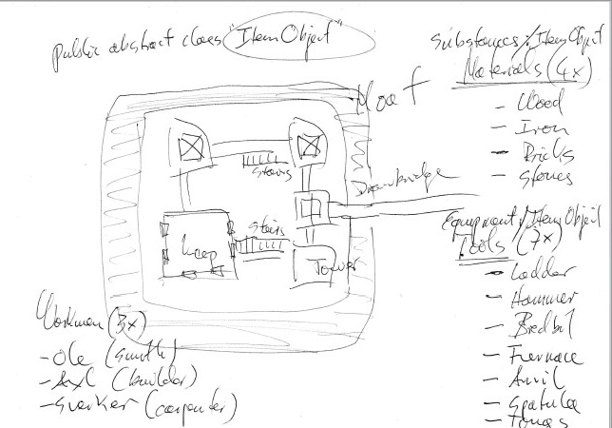

Further comments and background:

I have been making 3D-printable buildings, ships, as well as figurines, for three years now. As the collection is becoming larger, the temptation to interact with some of those creations in a game-like setting becomes irresistible. The infinite potential of the hundreds of thousands of 3D designs that my colleagues and I have been churning out and selling on the internet is my motivation for using Unity. What use is a 3D printed castle paperweight on your desk after a while if you cannot walk through it?